**Title**

The Effect of increasing salt concentration (mol dm3) on germination of mung beans over a period of 7 days

**Rationale**

For my A2 research paper I have chosen to look into seed germination, picking this study allows me to find out which are the best conditions for seeds to germinate and also allows me to look into what a seed is made up of and what is germination. This will help me understand why the seeds do not germinate. There are problems of salinity affecting poorer countries for example India, where a large portion of the sugar cane harvest has died and the yield of the crop is greatly decreased. In the last quarter of 2014 the “UN estimated the total area affects as 62 million hectares which is approximately the size of France” 5. The problems occur in areas of dry land with little rainfall and minimal drainage. The cause of the increase in salt is irrigation induced salinity. This is because in areas of dry land where there is a need for crop growth the only solution is to add large amounts of groundwater to the land to tend the soil. This causes problems as the water is often high in salt and when added to the soil the water is eventually used by plants or evaporated by the sun this leaves the salt in the soil and causes stress on the crop.

I aim to find out with research and practical work how salt affects seed germination and why salt is such a big problem for crops in the modern world. If we can understand why salt affects crops we can use different seeds to determine salt resistant genes and create GM crops for the places affected.

**Research**

A seed is formed during fertilization when the 2 haploid pollen nucleus fuses with the two polar nuclei to form the triploid nucleus and the other pollen nuclei joins with the haploid egg nucleus to form a diploid zygote. The triploid nucleus will become the endosperm will become the energy store through mitosis; it stores starch, oil and protein.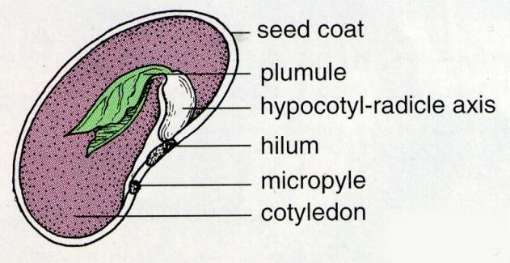

Germination

**Germination**

Germination is the process in which an embryo grows and develops into a mature adult plant. During early stages after dispersal the hard outer shell of the seed protects the embryo until suitable conditions occur before suitable conditions occur seed will remain in a dehydrated state which protects it from drought and extreme temperatures. When the conditions are right the seed takes in water through the micropyle this makes the tissue swell and the testa (seed coat) to become soft .the radicle grows first break through the testa and into the soil. The hypocotyl extends and pushes the plume up and out of the soil. The energy required for this process is found in the endosperm.

**What affects germination?**

In order to germinate healthy plants need water but in the early stages of germination plants do not need light as all its energy is stored within the seed as starch so light intensity will not affect germination. After plant has germinated it will need light or the shoot will start to yellow and die. This can cause rotting in seeds so in order to measure germination it would be best to remove seeds after germination to improve hygiene.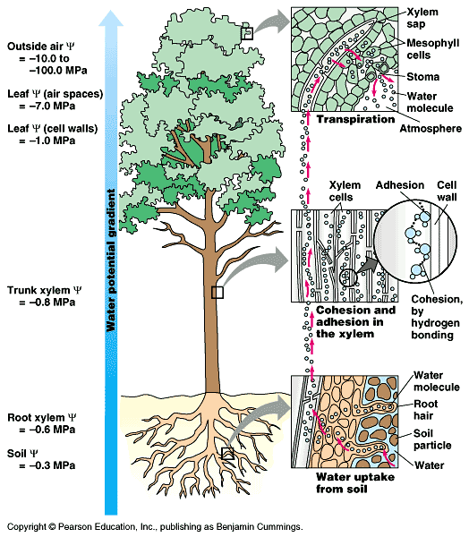

Plants also need a number of things from the soil including macro and micro nutrients. The primary macro nutrients include nitrogen, phosphorus, potassium, carbon, oxygen, hydrogen, and calcium.

Nitrogen in the soil is essential for the formation of amino acids and therefore proteins and cell division if the plant is lacking in nitrogen it will not grow. It also affects the energy reactions in plants and is need for photosynthesis. Phosphorus is needed for photosynthesis, respiration, energy storage and transfer, cell division and enlargement. It promotes root formation and development. It can also aid in survival during cold snaps and winter by increasing water efficiency. Potassium aids in carbohydrate metabolism and breakdown of starches it increases photosynthesis and winter hardiness and works to help plant to resist some diseases. Micro nutrients such as chlorine copper iron and manganese are also needed in small quantities.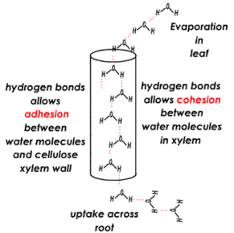

**Osmosis in plant cells**

Plants take up water through osmosis, water is drawn up through the roots and the cells swell making the plant cell turgid the pressure in the plant cell rises until the internal pressure is equal to outside pressure the turgor pressure prevents further net intake of water. This then allows the main leaves and stem of the plant to hold itself-up towards the sunlight. Water moves through the plant using the cohesion and surface tension. Hydrogen bonding between water molecules results in strong cohesive forces between the molecules; this keeps the water together as a continuous column in the xylem vessel. Adhesion- hydrogen bonds between cell wall and water molecule helps water travel up the xylem vessel.

The water moves into the roots through osmosis where it passes through a semi-permanent membrane with salt solution osmosis would reach a certain level

NaCl (salt) can interfere with osmosis. Osmosis is the movement of water from an area of high concentration to an area of low concentration. 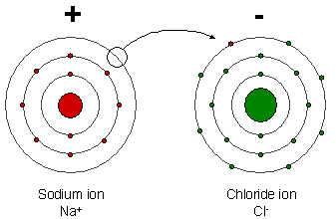

**Chemical makeup of salt**

Salt (sodium chloride) NaCl is made up of sodium and chloride. It’s readily soluble in water and separates into Na+ and Cl- ions salt

**Osmotic equilibrium and osmotic pressure**

*“Osmotic stress arises because the presence of salts (usually Na+) affects a plant's ability to absorb water and thus limits water availability to plant tissues.”6*

Osmotic pressure is the pressure created in an aqueous solution by a region of lower concentration to an area of higher solute concentration this forces water to the lower concentration to balance it out. If there is more salt concentration outside the seed the concentration of water going into seed would be lower as salt draws water out of seed as osmosis tries to balance. More salt prevents water from moving into the seed. When osmosis is affected the plant creates osmolytes this are soluble compounds which are found in the solution within a cell or surrounding solution. The osmolytes help maintain cell and fluid balance.

**Photosynthesis**

Water is needed in photosynthesis; it is split up in a reaction called photolysis. 2H2O -> 4e- +4H+ +O2 the electrons are used to replace those lost in chlorophyll during the light dependant stage when light hits chlorophyll and electrons become excited and move out of chlorophyll and down electron transfer chain. The 4 h+ are used in light independent stage during the Calvin cycle and the O2 is released as a waste product.  Photosynthesis turns water and carbon dioxide into glucose it produces a lot of the plants energy needed for respiration cells which in turn generates the proteins needed to make the plant grow. Without water the whole process of photosynthesis is not possible so the plants cells will die.

**Aim**

To find out the effect of salt concentration on mung beans and why it affects germination

**Working hypothesis**

There will be a significant correlation against increasing salt concentration against amount of seeds germinated

**Null hypothesis**

There will be no significant difference in amount of seeds germinated and the amount of increasing Mol of salt.

**Wider rational**

The information I gather from my experiments will show much salt in the water will affect the mung beans this can be applied to other beans and seeds. We can find out which are going to be the most affected areas in the world and apply aid there. You can work out the amount of salt in the soil by testing a soil sample using a salinity meter in a sample of soil dissolved in water. This can sow which areas are appropriate to grow crops and which areas of land are not possible to have crops on. A solution to salinity may be GM crops but currently here is a large proportion of modern population against genetic modifications which makes it hard as an option. testing a wide range seeds could show which crops are more tolerant I tested cress and mung to find cress is much more sensitive with little to no germination this can be applied to a wider range of seeds to benefit those living in areas of high salinity as well as determining plants with good tolerance to salt in their genes these can be the plants the genes are taken from for production of gm.

|  |  |  |  |
| --- | --- | --- | --- |
| Activity | Measuring out salt concentrations | Cleaning up | Measuring out solutions |
| Hazard | Could contaminate eyes with salt | Mould | Spillage |
| Persons in danger | Experimenter | Experimenter | Experimenter |
| Severity A 1-5 | 3 | 2 | 1 |
| Probability B 1-5 | 1 | 1 | 2 |
| Risk value AxB | 3 | 3 | 2 |
| Measures, comments to relate risk | Wear goggles | Keep lid on petri dish | Wear goggles and a lab coat |

When handling salt be careful not to touch eyes. The salt can irritate eyes and cause pain if entering. If you have an open or recent cut on your hand it may also cause irritation. If there is an open sore you could wear gloves. Eye goggles can stop salt going into eyes by creating a barrier between hands and eyes to prevent touching

Mould if consumed can cause problems including stomach ache and diarrhoea depending on types of mould. This can be prevented by thorough hand washing after removal of mouldy seeds. Tweezers are also an option. To prevent mild make sure you keep lid closed to avoid bacterial rain when a seed germinates removal will prevent mould

Spillage could be a problem if it is spilled on the floor it’s a slipping hazard so immediate attention will need to be applied.

**Course work trials write up**

For my first trial I tested a number of variations on the conditions I put the seeds in and the type of seeds to use. This will help me determine which are the best conditions to use in my final experiment. The results will show me best seeds cress or mung. The suitable medium paper towel cotton wool or none amount of water.

Trial 1

Equipment:

|  |
| --- |
| **Equipment** |
| 8 Petri dishes |
| 160 seeds (mung beans) |
| 100ml measuring cylinder |
| water |
| Cotton wool (8 pieces) |
| Paper towel (8 round discs) |

* I started by testing the best type of seed to use. In order to pick seeds I decided to use the seed with the most amount of germination that occurred of a period of days.
* I tested two types of seed mung beans and cress seeds.
* I tested the two types of seed on paper and on cotton wool with 15ml of water in each petri dish
* I used petri dishes as each dish has a lid so it offers some protection from bacterial rain/growth and it also control the amount of area the water/solution covers as it’s the using a petri dish means it’s the same for each seed
* For each petri dish I used 20 seeds I believe this amount of seeds was enough to represent germination as 10 would not accurately pick out anomalies
* I tested them in both light and dark conditions (light condition being on the window sill of the lab and dark condition in an empty cupboard of the lab.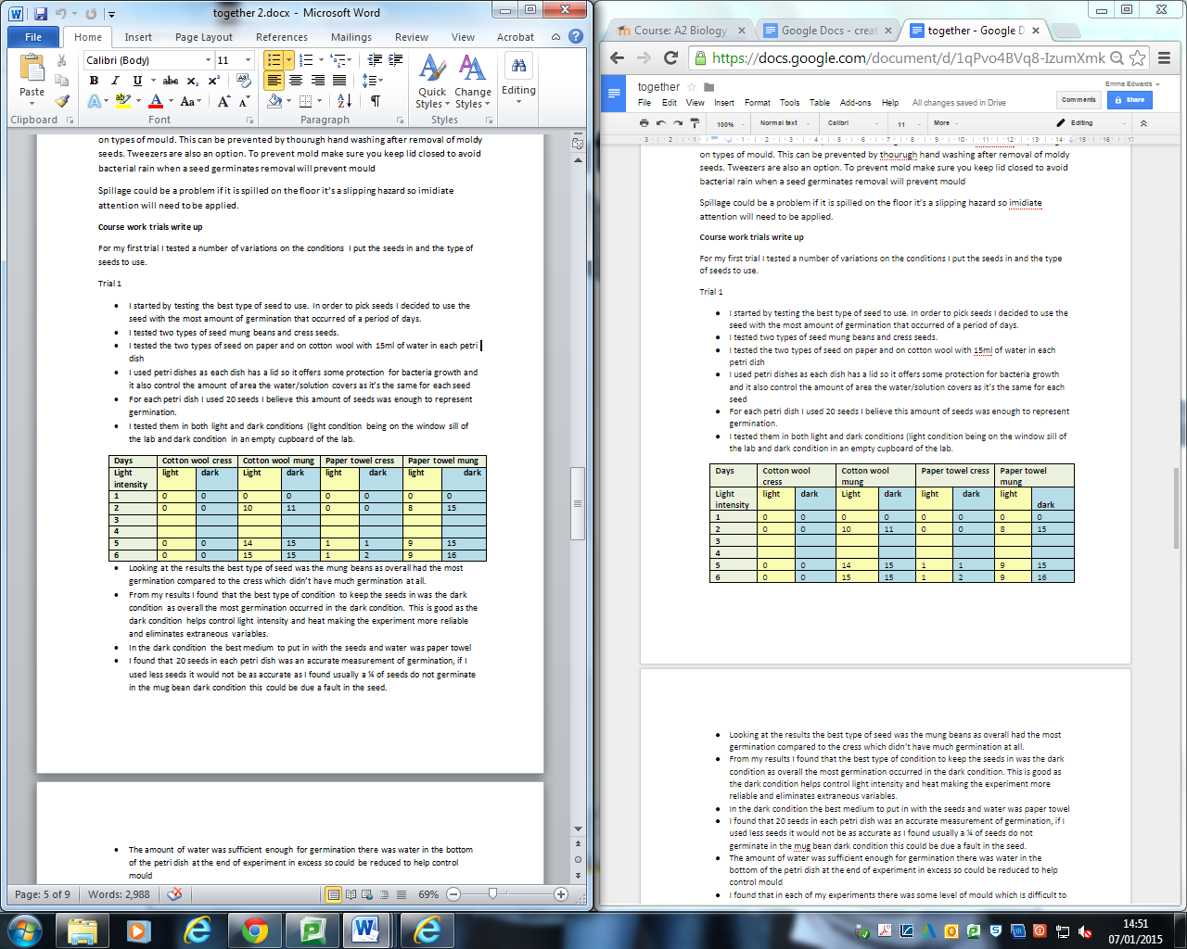

Results

* Looking at the results the best type of seed was the mung beans as overall had the most germination compared to the cress which didn’t have much germination at all.
* From my results I found that the best type of condition to keep the seeds in was the dark condition as overall the most germination occurred in the dark condition. This is good as the dark condition helps control light intensity and heat making the experiment more reliable and eliminates extraneous variables.
* In the dark condition the best medium to put in with the seeds and water was paper towel
* I found that 20 seeds in each petri dish was an accurate measurement of germination, if I used less seeds it would not be as accurate as I found usually a ¼ of seeds do not germinate in the mung bean dark condition this could be due a fault in the seed.
* The amount of water was sufficient enough for germination there was water in the bottom of the petri dish at the end of experiment in excess so could be reduced to help control mould
* I found that in each of my experiments there was some level of mould which is difficult to control.

Trail 2

|  |
| --- |
| **Equipment** |
| 1 mol salt solution (to dilute) |
| 10 Petri dishes |
| water |
| 100ml measuring cylinder |
| 10 paper towels |
| cupboard |
| seeds (mung beans) |

* In this trail I looked at salt concentrations 0.1mol dm-3,0.2mol dm-3, 0.3mol dm-3, 0.4,mol dm-3 , 0.5mol dm-3, 0.6mol dm-3, 0.7mol dm-3, 0.8mol dm-3, 0.9mol dm-3 and 1 mol dm-3
* I used 10 ml of solution this time in an attempt to reduce amount of mould
* Using 10 ml of solution makes it easier to accurately work out concentrations.
* I watched them over a 7 day period but there was a larger gap between day 2 and day 6 of a four day period this makes it harder to gauge when germination occurs for my final experiment I will look at the seeds over a five day period looking once per day. I found that after 0.4 mol dm-3 there was no germination up to 1 mol dm-3 which means that germination stops between 4 and 5 mol dm-3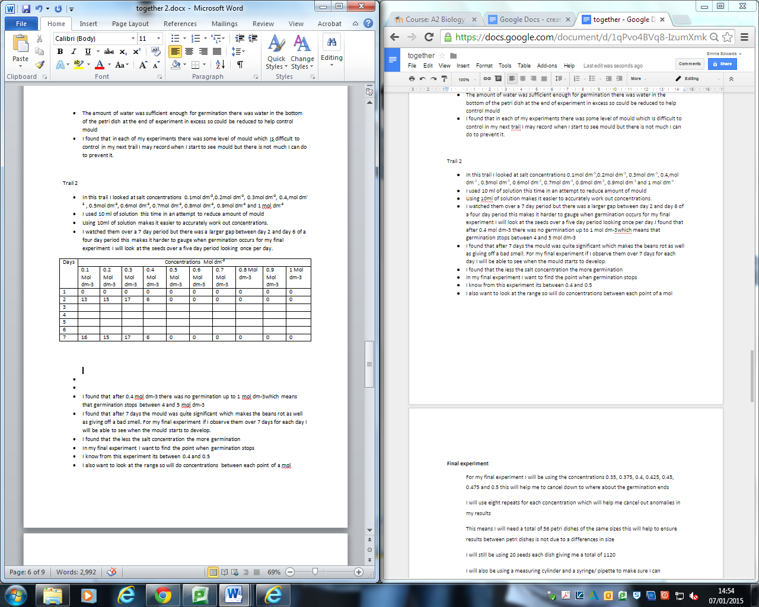
* I found that after 7 days the mould was quite significant which makes the beans rot as well as giving off a bad smell. For my final experiment if I observe them over 7 days for each day I will be able to see when the mould starts to develop. if the seed has already germinated I could remove it to prevent mould growth
* I found that the less the salt concentration the more germination
* In my final experiment I want to find the point when germination stops
* I found if I remove the mouldy seeds in some cases the mould would stay on paper towel and cause further rotting so paper towels may not be as good as just the petri dish.
* I know from this experiment its between 0.4 and 0.5
* I also want to look at the range so will do concentrations between each point of a mol

**Final experiment**

**Independent variable is salt concentrations**

**Dependant variable is amount of seeds germinated**

In my final experiment my independent variable is salt concentrations and my dependant variable is amount of seeds germinated.

one factor I need to control is the production of mould in my final experiment in my previous experiments I found mould to be the biggest problem as if seeds become mouldy they affect the seeds around them by speeding up production of mould. When I have paper towels although it was best out of the two mediums I tested the mould would stick to the towel and removal of the seed would still leave the mould so in my final experiment I will not use any medium to help prevent mould and risk contamination.

The adding salt concentration and removal of germinated seeds has to be done as quickly as possible. This is a precaution against bacterial rain and general bacteria in the air which may move onto the petri dish to reproduce. Making movements as quickly and efficiently as possible will help to prevent amount of bacteria coming into contact with dish.

making actions quick and ensuring the lid is on properly each time ensures limited evaporation will occur. If evaporation occurs it will distort the concentrations of the salt as the water will evaporate but salt will not making salt concentration higher. This may cause inaccuracies in the results

Making sure all of the petri dishes I use have completely flat unwarped bottoms. This will help salt solution cover an even amount of space. If the petri dish is warped salt solution may collect in the corners and amount of solution on each seed will vary. This may cause a problem if the seed is not able to reach the solution or all seeds are in one area.

For my final experiment I will be using the concentrations 0.35, 0.375, 0.4, 0.425, 0.45, 0.475 and 0.5 this will help me to cancel down to where about the germination ends

I will use eight repeats for each concentration which will help me cancel out anomalies in my results

This means I will need a total of 56 petri dishes of the same sizes this will help to ensure results between petri dishes is not due to a differences in size

I will still be using 10 seeds each dish giving me a total of 560

I will also be using a measuring cylinder and a syringe/ pipette to make sure I can accurately measure concentration.

Method

|  |
| --- |
| **Equipment** |
| 1 mol salt solution (to dilute) |
| 56 Petri dishes |
| Water |
| Syringe 10ml |
| Seeds (mung beans) |
| 100ml measuring cylinder |

1. I will gather 56 Petri dishes which will give me 8 repeats for each concentration and organise them into the 7 groups of concentrations
2. Using a 1 mol concentration of sodium chloride I will make up each of the 7 solutions using a measuring cylinder and syringe. The syringe is used to get the most accurate measurement possible with the equipment I have available
3. I will put 10 ml of each solution into 7 Petri dishes. I chose to do 10 ml as I think it will be the correct amount without encouraging the growth of mould
4. I will then put 10 seeds in each Petri dish. I have used 10 seeds as I believe it’s a good judgment of germination and it’s not as difficult to count I will put all the Petri dishes into the same cupboard to control heat and light intensity this will help eliminate extraneous variables
5. I will check the seeds each day for a period of 7 days in order to ensure I can record amount of germination before mould develops.

To record the data each day I will check the seeds to determine how many have germinated. When I have counted a germinated seed I will remove it to prevent mould development. I will then count amount of seeds left to determine how many have germinated me will then record it in a printed table before typing out my results.

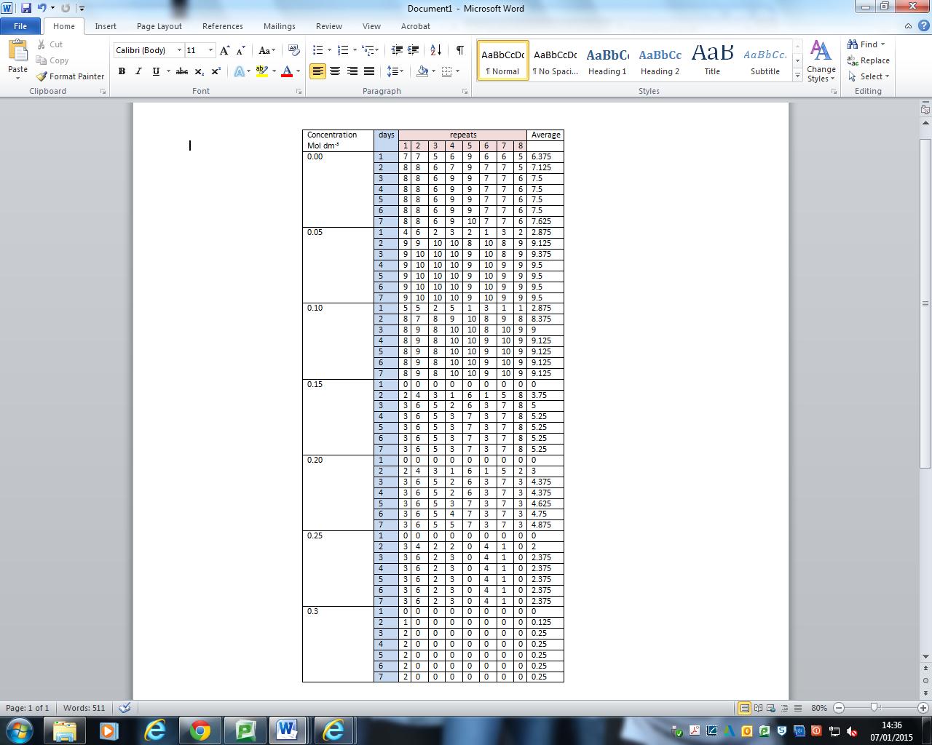

Raw data was recorded at 2 pm each day if the full amount of seed germinated (10) the seed were removed and the petri dish was washed to prevent development of mould the clean petri dish was put back in order to retain order.

This is a table of averages it uses only the data from day 7 to work out the standard deviation of my results this method allows me to find anomalies in my data

|  |  |  |  |  |  |  |  |
| --- | --- | --- | --- | --- | --- | --- | --- |
|  | Average seeds germinated | | | | | | |
| salt concentration mol dm3 | 0.00 | 0.05 | 0.10 | 0.15 | 0.20 | 0.25 | 0.3 |
| amount of seeds | 7.625 | 9.5 | 8.125 | 6.125 | 5.75 | 2.375 | 0.25 |

In my table of averages I can see that as the salt concentration the amount of seeds germinating decreases. 0.05 had the highest amount of germination (9.5) and 0.3 had the least amount of germination (0.25) the increase of 0.05 mol of salt increased germination from 7.625 to 9.5 but this is the highest point before decrease. 0.005 may be considered an anomaly but further tests results may be needed or they may turn up in statistical tests

|  |  |  |  |  |  |
| --- | --- | --- | --- | --- | --- |
| Concentration/ mol dm-3 | Mean seeds germinated | Standard deviation | Mean +2 (sd) | Mean -2 (sd) | Number of anomalies lying outside range |
| 0.00 | 7.625 | 1.316956719 | 10.2589134 | 4.991087 | 0 |
| 0.05 | 9.5 | 0.5 | 10.5 | 8.5 | 0 |
| 0.10 | 9.125 | 0.78062475 | 10.6862495 | 7.563751 | 0 |
| 0.15 | 5.25 | 1.920286437 | 9.09057287 | 1.409427 | 0 |
| 0.20 | 4.875 | 1.615355998 | 8.105712 | 1.644288 | 0 |
| 0.25 | 2.375 | 1.932453104 | 6.23990621 | -1.48991 | 0 |
| 0.30 | 0.25 | 0.661437828 | 1.57287566 | -1.07288 | 0 |

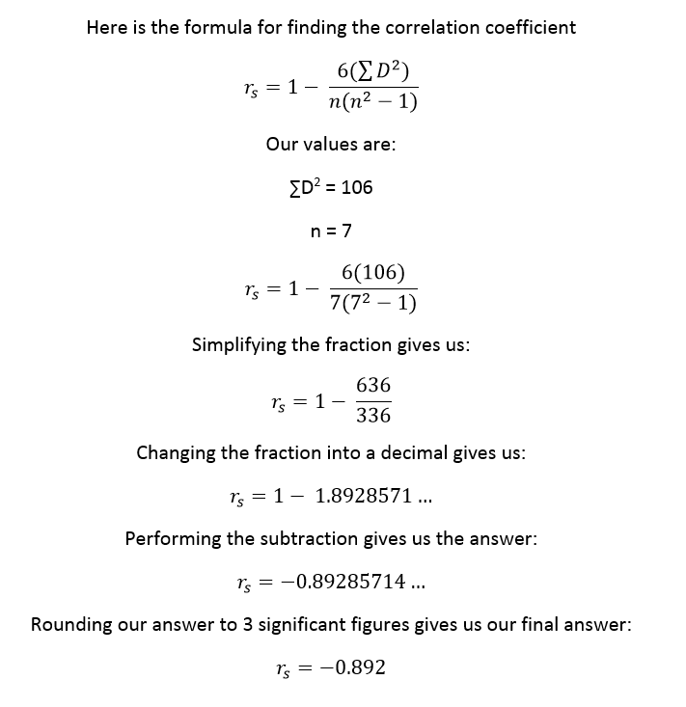

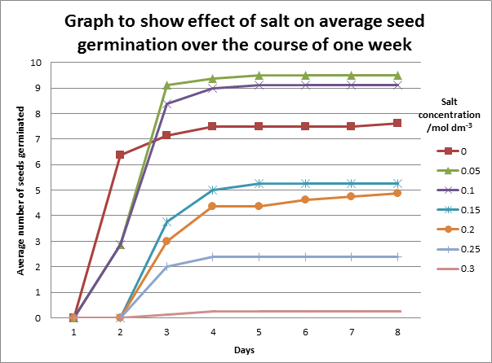

**Improvements**

Errors it’s difficult to measure salt concentration on such a small scale.

Peer review journal

Peer review journals publish articles and papers that have been reviewed by experts within the same field of research as the document is about. Peer review journals use single blind review or double blind reviews during the process. single blind review is where the reviewer's name is not known to the author of the paper/article or double blind review is where neither party has the name of reviewer or author so both are anonymous other less common processes may include open review or post publication open review.

There are many benefits to a peer review journal. The writer will receive detailed constructive feedback from experts in the field and this can help the writer know where the gaps in his/her research are and where improvements are needed. It can also allow input from the reviewers around the topic. Other pluses are that people who use the source or reference it can be sure its facts are up to scratch.

|  |  |  |  |  |
| --- | --- | --- | --- | --- |
|  | web link | type of source | page number an author | description |
| 1 | http://www.biology-resources.com/plants-seeds.html | scientific drawings | D G Mackean & Ian Mackean  page 1 | seed development |
| 2 | http://www.scielo.br/scielo.php?pid=S0100-83582010000300002&script=sci_arttext | research paper | Gorgan, Iran  page 1 | experiments to determine the effects of drought and salinity stress, temperature, pH and planting depth on clover (*Melilotus officinalis*) |
| 3 | http://www.eldoradochemical.com/fertiliz1.htm | informative web page | El Dorado Chemical Company  page 1 | Macro and micro nutrients and the importance of them to plants |
| 4 | http://www.etomica.org/app/modules/sites/Osmosis_old/Background1.html | text/web page | page 1  author n/a | this web page shows detailed information about osmosis |
| 5 | http://www.bbc.co.uk/news/science-environment-29800885 | news article | Melissa Hogenboom Science reporter, BBC News  page 1 | This BBC news article talks about the effects of salt and crops as stated by the un. I chose the BBC article as they are a trusty and well known reliable source. I used figures from this document in my rationale |
| 6 | http://www.plosone.org/article/info%3Adoi%2F10.1371%2Fjournal.pone.0022832#pone-0022832-g005 | peer review journal | Leah DeRose-Wilson,  Brandon S. Gaut mail  page 1 | mapping salt intolerance research paper |
| 7 | http://journalauthors.tandf.co.uk/review/peer.asp | facts | page 1 | facts about peer review journal |